Information Data

Place:
Auditorium :
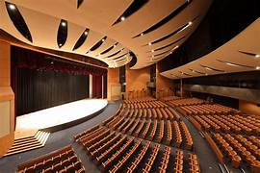
An auditorium is a room built to enable an audience to hear, watch performances and examming.

Studio Room:

A studio room is a dedicated space designed for specific creative or technical activities, such as audio recording, video production, photography, art creation, or even fitness training.

Meeting Room:
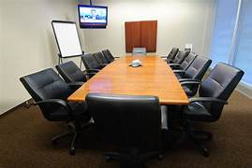
A meeting room is a dedicated space within an office or corporate environment where individuals or teams gather to discuss, collaborate, and make decisions.

Library:

A library is a dedicated space that houses a collection of books and other resources, providing a quiet and conducive environment for reading, studying, and research.

Recreation Room:

A recreation room, also commonly known as a rec room or game room, is a designated space within a residence or community where individuals can engage in various recreational activities and leisure pursuits.

